AMBULANCE SERVICES

A PROJECT REPORT

Submitted by,

Mr. Balu Ashok Kumar Reddy -20201CDV0036

Mr. Kasumurthy Vamsi -20201CDV0034

Mr Potlapati Babi Reddy -20201CDV0028

Mr. Vankayalapati Sai Charan -20201CDV0015

in partial fulfillment for the award of the degree

of

BACHELOR OF TECHNOLOGY

IN

COMPUTER SCIENCE AND ENGINEERING (Dev Ops).

Under the guidance of,

Dr. Srinivasan T. R.



PRESIDENCY UNIVERSITY

BENGALURU

JANUARY 2024

PRESIDENCY UNIVERSITY

SCHOOL OF COMPUTER SCIENCE AND ENGINEERING

CERTIFICATE

This is to certify that the Project report “AMBULANCE SERVICES APP” being submitted by “Balu Ashok Kumar Reddy, Kasumurthy Vamsi, K Potlapati Babi Reddy, Vankayalapati Sai Charan” bearing roll number(s) “20201CDV0036, 20201CDV0033, 20201CDV0028, 20201CDV0015” in partial fulfilment of requirement for the award of degree of Bachelor of Technology in Computer Science & Technology (Dev Ops) is a bonafide work carried out under my supervision.

|  |  |
| --- | --- |
| Dr. S HASAN HUSSAIN  Professor  School of CSE&IS  Presidency University | Dr. S Senthilkumar  Professor & HoD  School of CSE  Presidency University |

|  |  |  |
| --- | --- | --- |
| Dr. C. KALAIARASAN  Associate Dean  School of CSE&IS  Presidency University | Dr. SHAKKEERA L  Associate Dean  School of CSE&IS  Presidency University | Dr. SAMEERUDDIN KHAN  Dean  School of CSE&IS  Presidency University |

**PRESIDENCY UNIVERSITY**

**SCHOOL OF COMPUTER SCIENCE AND ENGINEERING**

**DECLARATION**

We hereby declare that the work, which is being presented in the project report entitled AMBULANCE SERVICES APP in partial fulfilment for the award of Degree of Bachelor of Technology in Computer Science and Technology (Dev Ops), is a record of our own investigations carried under the guidance of Dr. Srinivasan T.R, Professor, School of Computer Science & Engineering , Presidency University, Bengaluru.

We have not submitted the matter presented in this report anywhere for the award of any other Degree.

Balu Ashok Kumar Reddy -20201CDV0036

Kasumurthy Vamsi -20201CDV0033

Potlapati Babi Reddy -20201CDV0028

Vankayalapati Sai Charan -20201CDV0015

ABSTRACT

This Android application provides a user-friendly interface for users to view nearby ambulance services. By leveraging location-based services, the application can identify the nearest available ambulance services, providing users with real-time information. Users can book an ambulance and view their booking details in realtime, and the ambulance's location. The application's intuitive design and easy-to-use features make it a valuable tool for those in need of urgent medical attention.

Keywords: ambulance, user, driver, admin

ACKNOWLEDGEMENT

First of all, we indebted to the GOD ALMIGHTY for giving me an opportunity to excel in our efforts to complete this project on time.

We express our sincere thanks to our respected Dean Dr. Md. Sameeruddin Khan, School of Computer Science and Engineering & School of Information Science, Presidency University for getting us permission to undergo the project.

We record our heartfelt gratitude to our beloved Associate Deans Dr. C. Kalaiarasan and Dr. Shakkeera L, School of Computer Science and Engineering & Information Science, Presidency University and Dr. S Senthilkumar, Professor & Head of the Department, School of Computer Science and Engineering, Presidency University for rendering timely help for the successful completion of this project.

We are greatly indebted to our guide Srinivasan. T.R. , Professor ,

School of Computer Science Engineering & Information Science,

Presidency University for his/her inspirational guidance, and valuable

suggestions and for providing us a chance to express our technical

capabilities in every respect for the completion of the project work.

We would like to convey our gratitude and heartfelt thanks to the

University Project-II Coordinators Dr. Sanjeev P Kaulgud,

Dr. Mrutyunjaya MS and also the department Project Coordinator

Dr. Srinivasan. T.R.

We thank our family and friends for the strong support and inspiration

they have provided us in bringing out this project.

Balu Ashok Kumar Reddy

Kasumurthy Vamsi

Potlapati Babi Reddy

Vankayalapati Sai Charan

LIST OF TABLES

|  |  |  |  |
| --- | --- | --- | --- |
| Sl. No. | Table Name | Table Caption | Page No. |
| 1 | Table 8.2.7.1 | Testing Cases | 31 |

LIST OF FIGURES

Sl. No. Figure Caption Page No.

Name

1. Figure 5.1 ARCHITECTURE 16
2. Figure 5.2 AGILE MODEL 17
3. Figure 7.1 USE CASE DIAGRAM 21
4. Figure 7.2 CLASS DIAGRAM 22
5. Figure 7.3 SEQUENCE DIAGRAM 23
6. Figure 7.4 COLLABORATION DIAGRAM 24
7. Figure 7.5 ACTIVITY DIAGRAM 25
8. Figure 7.6 COMPONENT DIAGRAM 26
9. Figure 7.7 DEPLOYMENT DIAGRAM 26
10. Figure A HOME PAGE 40
11. Figure B REGISTER PAGE 40
12. Figure C ADMIN LOGIN PAGE 41
13. Figure D TRACKING PAGE 41
14. Figure E USER PAGE 42

15 Figure F BOOKING PAGE 43

# TABLE OF CONTENTS

## CHAPTER. N0 PAGE.NO

CERTIFICATE I

DECLARATION II

ABSTRACT III

ACKNOWLEDGEMENT IV

1 INTRODUCTION 1

## 2 REQUIREMENT ANALYSIS 2

2.1 HARDWARE COMPONENT 2

2.2 SOFTWARE COMPONENT 3

3 LITERATURE SURVEY 11

4 RESEARCH GAPS OF EXISTING METHODS 13

## 5 PROPOSED METHODOLOGY 15

5.1 ARCHITECTURE 16

5.2 System Development Cycle 17

6 OBJECTIVES 18

## 7 7 SYSTEM DESIGN & IMPLEMENTATION 20

7.1 Use case Diagram 21

7.2 Class Diagram 22

7.3 Sequence Diagram 23

7.4 Collaboration Diagram 24

7.5 Activity Diagram 25

7.6 Component Diagram 26

7.7 Deployment Diagram 26

## 8 SYSTEM STUDY 27

8.1 Feasibility study 27

8.2 Types of Testing 28

8.2.1 Unit Testing 28

8.2.2 Integration Testing 28

8.2.3 Functional Testing 29

8.2.4 System Testing 29

8.2.5 White Box Testing 29

8.2.6 Black Box Testing 29 8.2.7 Acceptance Testing 30

1. TIMELINE FOR EXECUTION PROJECT(GANTT CHART) 32
2. OUTCOMES 33
3. CONCLUSION 35
4. REFERENCES 36

CHAPTER-1

INTRODUCTION

This Android application is an innovative solution that aims to revolutionize the way people access medical assistance during emergencies. Its primary objective is to provide a convenient and efficient way for users to locate nearby ambulance services. The app uses advanced location-based services to quickly identify the nearest available ambulance services and provide users with real-time information, including estimated arrival times and the ambulance's location. This means that users can access vital information about the ambulance's location and the estimated time of arrival, which can be the difference between life and death in emergency situations. The user interface of the application is designed to be intuitive and user-friendly, enabling users to navigate the app with ease. It allows users to book an ambulance quickly and efficiently, and they can view their booking details in realtime, including the estimated time of arrival and the ambulance's location. This feature ensures that users can stay informed about the progress of their ambulance and can make informed decisions about their next steps.

Overall, this application is a valuable tool for anyone in need of urgent medical attention. It is an essential tool for people who live in densely populated urban areas, where traffic congestion and other challenges can hinder emergency services. With this app, users can access vital information about ambulance services, book an ambulance quickly and efficiently, and monitor their progress in real-time. The app is designed to make the process of accessing emergency medical assistance as seamless and stress-free as possible, and it is an important step forward in improving the quality of emergency medical services

CHAPTER-2

REQUIREMENT ANALYSIS

1. Hardware Components
2. Software Components

* 1. Hardware Components

2.1.1 i5 Processer

Intel processors are the most often utilised CPUs for desktops and notebooks globally. They are available in a number of model families under the names Core, Xeon, Pentium, or Celeron. The ninth, tenth, or eleventh generations, often referred to as Coffee Lake and Rocket/Tiger Lake, are only a few of the many generations that they come in. These typical word processors, together with versions made for better speed, mobility, creative processes, performance in gaming, big data, and various other applications, power almost all of PCs on the market.

AN INTEL PROCESSOR'S PARTS

* + - Core, Xeon, Pentium, or Celeron are examples of brands that refer to an entire product series.
    - Generation indicator: A generation indication, such as 9, 10, or 11, comes right after the brand and adjective in the SKU number sequence. This reveals the date of chip creation. 2019– 2020 saw the release of 10th Gen Intel processors, with 11th Gen following in 2020–2021. SKU: This is a model number that is more particular within every company and generation. Typically, a higherItem category: You may determine what each Intel CPU is typically intended for by looking at the item's line suffix on the very end of each processor name. For instance, a Core 2 Duo processor with a "XE" at the end of its name is a highperformance desktop CPU.

The i5 Processor is a type of central processing unit (CPU) manufactured by Intel

Corporation, designed for use in consumer and business desktop and laptop computers. It belongs to the Core processor series from Intel and is positioned in the middle of the entry- level i3 and premium i7 variants. Because they balance performance and price, i5 CPUs are popular choices for routine computing tasks including surfing the web, writing, driving light video editing. Most i5 processors include many cores that enable them to do various activities at once as well as features like hyper-threading, which enables each CPU core to work across multiple threads of instructions simultaneously. Specifications:-

* + - Intel Core i5 processors:(3.0-MB L3 cache, dual core, 35 W)
    - 3230M 2.60- GHz processor (3.0-MB L3 cache, dual core, 35 W) 711903-001
    - 3210M 2.50-GHz processor 680645-001 Applications of i5 Processor:
    - Gaming
    - Video editing
    - 4K videos as well as
    - A few other less intensive resource tasks.

Working of i5 Processor:

The hardware specifications and software you select to run it both have an impact on how the Intel Core i5 processor functions. If you use this CPU for any work that necessitates intensive multithreading, especially video encoding, its performance may be severely constrained. This is due to the i5 Core's incapacity for hyper threading.

Faster Browsing:

Due to the high RAM capacity, You may explore more quickly and receive quicker results in seconds because of the high RAM capacity. You can multitask on your preferred browser while having multiple tabs open without worrying about it crashing or getting too hot. The recommended amount of RAM for quickest web browsing is 8GB.

Lag Relief:

Using 4GB of RAM or less won't cause your PC to lag constantly. The bigger memory size and relatively quicker job processing make multitasking easier than before.

TB Hard Disk:

A terabyte, or 1TB, is 1,099,511,627,776, or around 1100GB, of data. Manufacturers of hard drives use a separate table that doesn't accurately translate 1TB to 1000GB. Thus, a 1TB hard drive typically offers 930Gbytes of storage space.

2.2 SOFTWARE

### 2.2.1 Windows Operating System

The graphical operating system Microsoft Windows, also referred to as Windows or Win, was developed and launched by Microsoft. It provides a way to store files, run programmes, play games, watch videos, and connect to the Internet.

Beginning with Windows XP, Microsoft has produced a number of different Windows editions. While the base operating system is the same across all of various Windows editions, several editions additionally include additional features and can be purchased individually. An important element of a computer Graphical (graphical user interface) is often a window. Features:

* Start Menu- As the name suggests, the user starts his or her actions at this stage after powering on the computer. On the start menu, a list of all the installed, pinned, and recently used programmes is available. We can navigate through many different files and programmes by using the search bar. There are choices for switching the user, turning off, rebooting, and entering sleep mode. As a result, a start is simply a site where people can begin their task by choosing the ideal area for doing so.
* File Explorer- In daily life, we keep every bit of our paperwork in one place and organize it by use and necessity. The similar function is performed by the Windows file explorer. It saves each and every one of our records in the sequence we specify to the directory we choose. Here are all the areas where we inserted the removable discs and pens. The ability to insert, create shortcuts, rename, delete, group, and perform other operations on different files is another feature we have. It is simpler to find files thanks to the search option. Also accessible through file explorer are the most recent documents we've used.

Control Panel- It maintains and configures the resources and software on our computer, as its name suggests. Depending on the needs of the user, many actions can be conducted. Here, you may manage your system and set the time, among other things. If we want to connect our computer with devices, the settings as well as a few network-related characteristics can be changed here. The system parameters can be used and altered entirely at the discretion of the user

* Browser (Edge)- Microsoft Edge is the default browser on Windows. The browser is able to be used to browse the internet and do online research. Windows comes with an installed browser. The default browser was once Internet Explorer, but Edge has now taken its place. It returns results for searches more rapidly thanks to security measures such protection against viruses, phishing mitigation, and the identification of harmful websites.
* Task Manager- The task manager is used to oversee all of the open tasks. We can find out what tasks are taking place in the background and compel those that are currently executing to stop. Both the foreground and background running programmes can be stopped by using the 'End Task' command. We also discover how much the CPU, RAM, and memory are used by each system resource.

2.2.2 Database

A organised collection of information that is stored and accessible electronically is known as a database. Large databases are held on computer networks as well as in the cloud, whilst small databases are frequently saved by a file system. A few of the practical considerations that go into database design include data modelling, effective data presentation, query languages, security, and failure tolerance.

A database in My SQL Server consists of a collection of tables that contain data, and other objects, such as views, indexes, stored procedures, and triggers, defined to support activities performed with the data. The data stored in a database is usually related to a particular subject or process, such as inventory information for a manufacturing warehouse.

SQL Server can support many databases, and each database can store either interrelated data or data unrelated to that in the other databases. For example, a server can have one database that stores personnel data and another that stores product-related data. Alternatively, one database can store current customer order data, and another; related database can store historical customer orders that are used for yearly reporting. Before you create a database, it is Important to understand the parts of a database and how to design these parts to ensure that the database performs well after it is implemented.

### 2.2.3 Google Firebase

Googles Firebase modular setup allows developers to choose specific services based on their apps

needs and easily integrate them into their projects.

Real-time Database: A NoSQL cloud database that enables syncing data between users in real-time.

Cloud Storage: Offers secure file uploads and downloads for user-generated content.

Performance Monitoring: Monitors app performance and helps identify performance bottlenecks.

Android Studio:

Android Studio is the official integrated development environment(IDE) for Android app development, which is created by Google. It is based on IntelliJ IDEA, a popular IDE from JetBrains and provides a comprehensive set of features for developing Android apps. Android studio also supports the development of apps for Wear OS, Android TV and other Android Platforms. There are some key features for Android app studio

Key Features of Android app studio:

* Development Environment:

Integrated Development Environment (IDE): Powerful IDE like Android Studio with code editors, visual layout builders, debuggers, and resource managers for efficient coding and design.

* Kotlin and Java Support: Develop apps using either Kotlin or Java, the official languages for Android development.
* Project Management: Tools for managing project files, dependencies, and configurations.
* Version Control Integration: Integrate with version control systems like Git for collaborative development and project history tracking.
* Gradle Build System: Powerful build system for managing dependencies, generating different build variants (e.g., debug, release) for different devices.
* Emulator and Device Support: Run and test your app on virtual devices (emulators) and physical devices connected to your computer.
* Debugging Tools: Debuggers and profilers to identify and fix bugs and optimize app performance.
* Live Edit: See changes in your code reflected instantly on running devices for faster development iteration.
* Visual Layout Editor: Drag-and-drop tools for building user interfaces (UI) with widgets and layouts.
* Google Play Services Integration: Access Google Play services such as Google Maps, and Firebase directly from your app.

CHAPTER-3

LITERATURE SURVEY

[1]. Mohammad Abdeen; Mohamed Hossam Ahmed; Hafez Seliem; Mustafa El-Nainay; Tarek Rahil Sheltami; Improving the Performance of Ambulance Emergency Service Using Smart Health Systems;16-17 December 2021.

Smart health is a new paradigm that can significantly improve the healthcare systems. In smart health, novel sensing, computing and communication technologies are integrated in healthcare to improve the quality of service. In this paper, we use the smart health to improve the performance of ambulance service. In particular, we use the real-time traffic information and hospital waiting time to minimize the ambulance response time, ambulance travel time to hospitals, and waiting time at hospitals. Results indicate that the use of smart health improves the performance significantly especially with non-uniform hospital capacity and non-uniform traffic conditions.

[2]. P. Thirumoorthi; M Deeparasi; J Hariprakash; Akshayamathi M; K Premalatha; Development of Smart System for Ambulance08-09 October 2021.

Traffic congestion becomes a major issue in densely populated metropolitan areas. India is the world’s second most populous country and has a rapidly rising economy. In the cities, there is severe traffic congestion. According to the Times of India, nearly 30% of deaths are caused by ambulances arriving late to the hospital. We are attempting to shorten the wait for the ambulance. To smoothen the ambulance movement, “Smart Ambulance” system is proposed in this paper. The proposed system allows to switch signals in the particular lane where the ambulance is present. RF module is used for communication. The system in the “Smart ambulance” is designed to activate when it receives a signal from an ambulance via radio frequency (RF) transmission, and Arduino is used to modify the sequence back to normal before and after the emergency mode is engaged. In second phase, a system is developed in which medical records are stored. This data will help the medical staffs to save time in the hospital to make necessary arrangements for the treatment of patients. The data can be retrieved by using unique fingerprint authentication. This generated data will be sent to the nearest hospital using GPS module. This paper proposes the system to save human life.

[3]. S. Sasipriya; Arfana Suraiba R; Ajaai R; Harini S; Accident Alert and Ambulance Tracking System; 08-10 July 2021.

A mobile tracking application for emergency ambulance services is proposed in this paper with various challenges in vehicle tracking and monitoring system. The system issues alert messages in case of emergency. The alert system is essential to provide information about the location of the accident or driver's location. In the conventional method, the ambulance driver could not reach the accident location on time due to heavy traffic, leading to loss of many lives. With the current technological advancements in smartphones and mobile apps, a mobile app for tracking ambulance in real time is proposed in this paper. This application will let the ambulance driver record its availability and location. The user who executes the emergency will book the ambulance and log in to the user. The user location and nearby ambulances will be precisely pointed out on the Google map. Once the patient is boarded, the location of the ambulance will be recorded and sent to the traffic police present at the traffic signal. The driver then selects the nearby hospital on the map, which helps to treat the patients on time. The location of ambulance is tracked by the navigator based on Web Services. This technology will help the ambulance location to be updated in the database. In addition, the traffic signal can be controlled based on the upcoming ambulance vehicle thus providing a traffic less route.

CHAPTER-4

RESEARCH GAPS OF EXISTING METHODS

* While reviewing the literature on ambulance services, several research gaps become apparent, indicating areas where further investigation and scholarly inquiry are needed. These research gaps include:
* Comprehensive Global Comparison: The majority of the literature primarily focuses on developed countries, particularly the UK, the USA, Canada, and Australia. A research gap exists in the exploration of ambulance services in developing regions, where unique challenges and opportunities may shape emergency healthcare differently. A comprehensive global comparison would contribute to a more nuanced understanding of ambulance service dynamics across diverse socio-economic contexts.
* Longitudinal Analysis of Trends: Many studies provide snapshots of ambulance service utilization over specific periods, hindering a comprehensive longitudinal analysis. Research should aim for more extended temporal perspectives to identify evolving trends, contributing factors, and the sustainability of current emergency healthcare systems.
* Impact of Technological Advancements: While some studies touch upon the integration of smart health technologies and systems, there is a research gap in understanding the comprehensive impact of technological advancements on ambulance services. Further exploration is needed to assess the effectiveness of cutting-edge technologies, such as artificial intelligence, real-time data communication, and Internet of Things (IoT), in improving response times and patient outcomes.
* Cultural and Societal Influences: The reviewed literature provides limited insights into the cultural and societal influences shaping ambulance service utilization. Research exploring how cultural attitudes, beliefs, and societal expectations impact the decisionmaking process regarding emergency healthcare seeking behavior would contribute to a more holistic understanding.
* Patient and Caregiver Perspectives: While much of the literature focuses on quantitative data, there is a research gap in qualitative studies exploring the perspectives of patients and their caregivers. Understanding the lived experiences, preferences, and challenges faced by individuals during emergencies could inform patient-centered interventions and enhance the overall quality of ambulance services.
* Interdisciplinary Approaches: The complexity of factors influencing ambulance service utilization necessitates interdisciplinary research. Collaboration between healthcare professionals, social scientists, technologists, and policymakers is crucial for developing holistic solutions that address not only the medical aspects but also the social, cultural, and technological dimensions of emergency healthcare.
* Effectiveness of Health Awareness Campaigns: Although health awareness campaigns are acknowledged as influencers of healthcare-seeking behavior, there is a gap in research assessing the long-term effectiveness of such campaigns. Investigating the sustained impact and potential unintended consequences of mass media health promotions would provide valuable insights for future public health initiatives.
* Alternative Care Models: The literature acknowledges challenges in triage and alternative care, but there is a research gap in evaluating the effectiveness of various alternative care models. Research should explore community-based services, telehealth options, and innovative approaches that divert non-emergency cases away from traditional emergency services, ensuring appropriate and timely care.
* Addressing these research gaps would contribute to a more comprehensive and nuanced understanding of ambulance services, enabling the development of evidencebased interventions, policies, and practices that align with the evolving needs of diverse populations and healthcare systems.

EXISTING METHOD

In Existing the Ambulance service apps where mostly filled with Ads and the user details weren’t safe and secure in the application.

Disadvantages

* Excessive ads compromise user experience in current ambulance service apps.
* Inadequate security raises concerns about user data safety.
* Enhanced privacy protocols are critical for instilling user confidence.

CHAPTER-5

PROPOSED METHODOLOGY

The proposed system is an Android application that allows users to quickly and easily locate and book nearby ambulance services. The system utilizes location-based services to identify the nearest available ambulance services, providing users with real-time information on estimated arrival times and other important details. The system's user-friendly interface allows users to easily book an ambulance and view their booking details in real-time, and the ambulance's current location. Additionally, the system will feature an intuitive design and easy-to-use features, making it a valuable tool for those in need of urgent medical attention. With this proposed system, users can rest assured that they will be able to quickly and efficiently book emergency medical services whenever they need them.

Advantages

* Android app: Locate, book nearby ambulances, real-time updates on availability.
* User-friendly interface: Easily book, track ambulance, view real-time details.
* Quick, efficient emergency medical service booking for urgent medical attention.

SOFTWARE DEVELOPMENT LIFE CYCLE

Although there are a growing number of applications (such as decision support systems) that should be developed using an experimental process strategy such as prototyping, a significant amount of new development work continue to involve major operational applications of broad scope. The application systems are large highly structured. User task comprehension and developer task proficiency is usually high. These factors suggest a linear or iterative assurance strategy. The most common method for this stage class of problems is a system development life cycle modal in which each stage of development is well defined and has straightforward requirements for deliverables, feedback and sign off. The system development life cycle is described in detail since it continues to be an appropriate methodology for a significant part of new development work.

The basic idea of the system development life cycle is that there is a well-defined process by which an application is conceived and developed and implemented. The life cycle gives structure to a creative process. In order to manage and control the development effort, it is necessary to know what should have been done, what has been done, and what has yet to be accomplished. The phrases in the system development life cycle provide a basis for management and control because they define segments of the flow of work, which can be identified for managerial purposes and specifies the documents or other deliverables to be produced in each phase.

The phases in the life cycle for information system development are described differently by different writers, but the differences are primarily in the amount of necessity and manner of categorization. There is a general agreement on the flow of development steps and the necessity for control procedures at each stage.

The information system development cycle for an application consists of three major stages.

Definition.

Development.

Installation and

Operation.

The first stage of the process, which defines the information requirements for a feasible cost effective system. The requirements are then translated into a physical system of forms, procedures, programs etc., by the system design, computer programming and procedure development. The resulting system is test and put into operation. No system is perfect so there is always a need for maintenance changes. To complete the cycle, there should be a post audit of the system to evaluate how well it performs and how well it meets the cost and performance specifications. The stages of definition, development and installation and operation can therefore be divided into smaller steps or phrases as follows.

**Definition**

Proposed definition : preparation of request for proposed applications.

Feasibility assessment: evaluation of feasibility and cost benefit of proposed system.

Information requirement analysis: determination of information needed.

**Design**

Conceptual design : User-oriented design of application development.

Physical system design: Detailed design of flows and processes in applications processing system and preparation of program specification.

**Development**

Program development : coding and testing of computer programs.

Procedure development : design of procedures and preparation of user instructions.

Installation and operation

Conversion : final system test and conversion.

Operation and maintenance: Month to month operation and maintenance

Post audit : Evaluation of development process, application system and results of use at the completion of the each phase, formal approval sign-off is required from the users as well as from the manager of the project development.

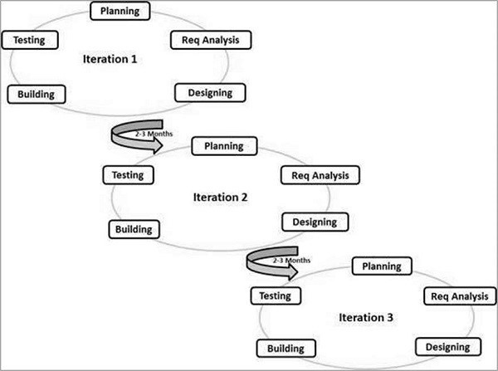

### 5.2 System Development Cycle.

CHAPTER-6

OBJECTIVES

1. Response Time Improvement: Decrease response times to emergencies by implementing efficient dispatch systems, optimizing routes, and streamlining protocols.

1. Enhanced Training and Equipment: Ensure all personnel receive regular, updated training and have access to cutting-edge equipment to improve patient care and outcomes.

1. Patient Care Quality: Focus on delivering high-quality, compassionate care by implementing best practices, standardized protocols, and continuous quality improvement initiatives.

1. Community Outreach and Education: Develop programs to educate the public on when and how to utilize ambulance services effectively, thereby reducing unnecessary emergency calls.

1. Technology Integration: Leverage technology advancements for better communication, data management, and medical equipment integration within ambulances for improved efficiency and patient care.

1. Collaboration with Healthcare Providers: Strengthen partnerships with hospitals, clinics, and other healthcare entities to create a seamless continuum of care for patients.

1. Risk Management and Safety Measures: Implement rigorous safety protocols to protect both patients and emergency responders during transit and at the scene.

1. Financial Sustainability: Optimize operational efficiency to maintain a sustainable financial model without compromising the quality of service.

1. Continuous Evaluation and Improvement: Regularly assess performance metrics, gather feedback from patients and staff, and use this data to refine and improve ambulance services continually.

1. Adaptation to Changing Needs: Remain agile and adaptable to evolving community needs, emerging medical trends, and technological advancements to stay at the forefront of emergency medical services.

* + Our Vision
  + A pioneering , resilient , and sustainable ambulance service model.
  + Our Mission
  + To regulate and provide specialized, agile, and sustainable ambulance services that foresee the future, by talented workforce empowered with the most current knowledge, and advanced technologies, and through institutional and societal partnerships to serve our community.
  + Our Values
  + Positivity
  + Professionalism
  + Team spirit
  + Integrity
  + Pride
  + Reliable

CHAPTER-7

SYSTEM DESIGN & IMPLEMENTATION

IMPLEMENTATION

Modules :

User: The proposed system enables users to sign up and log in using their credentials. They can then access the application's functionality, which includes viewing nearby ambulance services, booking an ambulance as required, and accessing their booking history through the history activity. This system simplifies the process of booking an ambulance for users and provides them with the necessary information.

Admin: Admin can add Ambulance drivers and view the list user in the app.

Ambulance Driver: Ambulance driver can view the booking history which are booked by the user and the driver can accept the drive.

SYSTEM DESIGN

UML DIAGRAMS

UML stands for Unified Modeling Language. UML is a standardized general-purpose modeling language in the field of object-oriented software engineering. The standard is managed, and was created by, the Object Management Group.

The goal is for UML to become a common language for creating models of objectoriented computer software. In its current form UML is comprised of two major components: A Meta-model and a notation. In the future, some form of method or process may also be added to; or associated with, UML.

The Unified Modeling Language is a standard language for specifying, Visualization, Constructing and documenting the artifacts of software system, as well as for business modeling and other non-software systems.

The UML represents a collection of best engineering practices that have proven successful in the modeling of large and complex systems.

The UML is a very important part of developing objects-oriented software and the software development process. The UML uses mostly graphical notations to express the design of software projects.

GOALS:

The Primary goals in the design of the UML are as follows:

1. Provide users a ready-to-use, expressive visual modeling Language so that they can develop and exchange meaningful models.
2. Provide extendibility and specialization mechanisms to extend the core concepts.
3. Be independent of particular programming languages and development process.
4. Provide a formal basis for understanding the modeling language.
5. Encourage the growth of OO tools market.
6. Support higher level development concepts such as collaborations, frameworks, patterns and components.
7. Integrate best practices.

Use Case Diagram:

A use case diagram in the Unified Modeling Language (UML) is a type of behavioral diagram defined by and created from a Use-case analysis. Its purpose is to present a graphical overview of the functionality provided by a system in terms of actors, their goals (represented as use cases), and any dependencies between those use cases. The main purpose of a use case diagram is to show what system functions are performed for which actor. Roles of the actors in the system can be depict

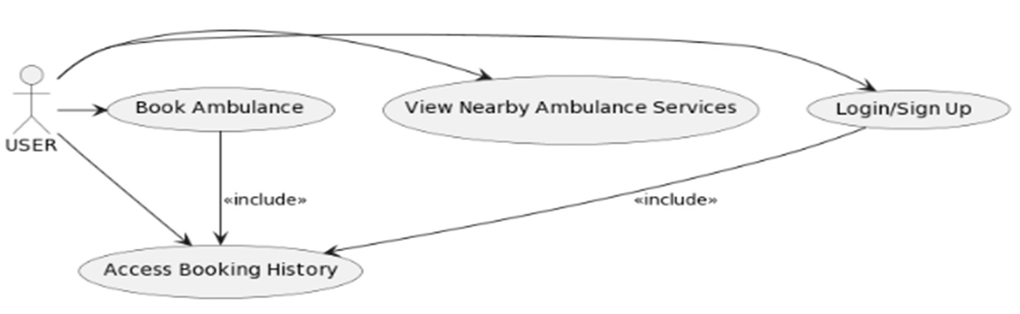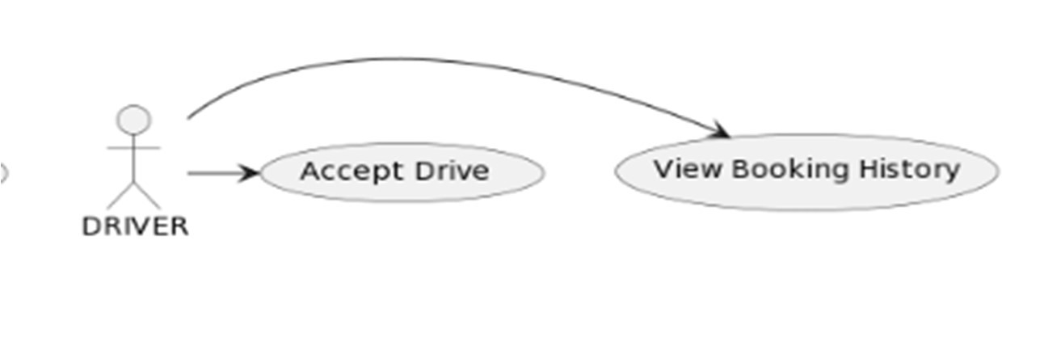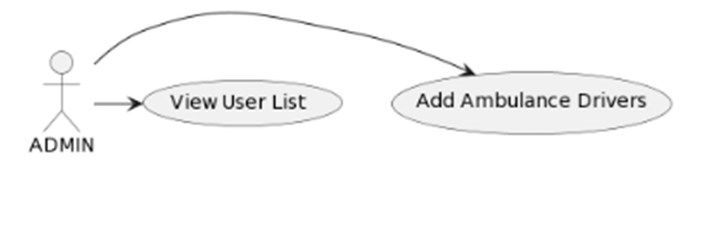

* 1. Use Case Diagram

Class Diagram:

In software engineering, a class diagram in the Unified Modeling Language (UML) is a type of static structure diagram that describes the structure of a system by showing the system's classes, their attributes, operations (or methods), and the relationships among the classes. It explains which class contains information.

**ADMIN:**

**USERS:**

* 1. Class Diagram

Sequence Diagram:

A sequence diagram in Unified Modeling Language (UML) is a kind of interaction diagram that shows how processes operate with one another and in what order. It is a construct of a Message Sequence Chart. Sequence diagrams are sometimes called event diagrams, event scenarios, and timing diagrams.

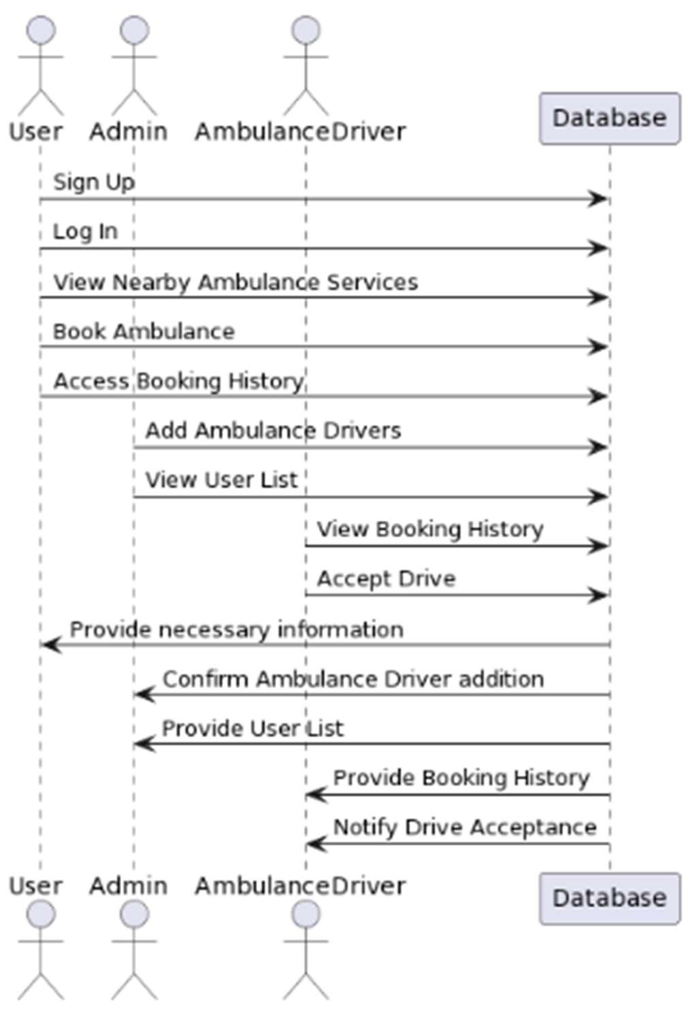

7.3 Sequence Diagram Collaboration Diagram:

In collaboration diagram the method call sequence is indicated by some numbering technique as shown below. The number indicates how the methods are called one after another. We have taken the same order management system to describe the collaboration diagram. The method calls are similar to that of a sequence diagram. But the difference is that the sequence diagram does not describe the object organization whereas the collaboration diagram shows the object organization.

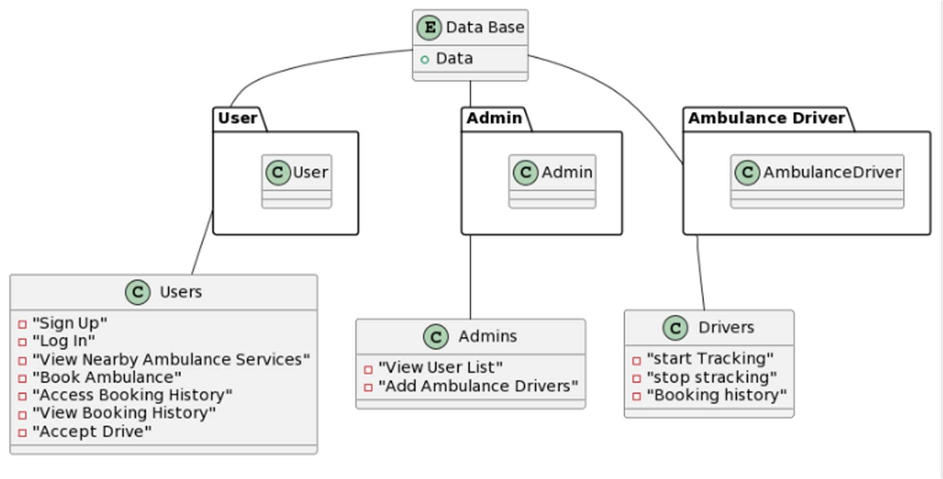

7.4 Collaboration Diagram

Activity Diagram:

Activity diagrams are graphical representations of workflows of stepwise activities and actions with support for choice, iteration and concurrency. In the Unified Modeling Language, activity diagrams can be used to describe the business and operational step-by-step workflows of components in a system. An activity diagram shows the overall flow of control.

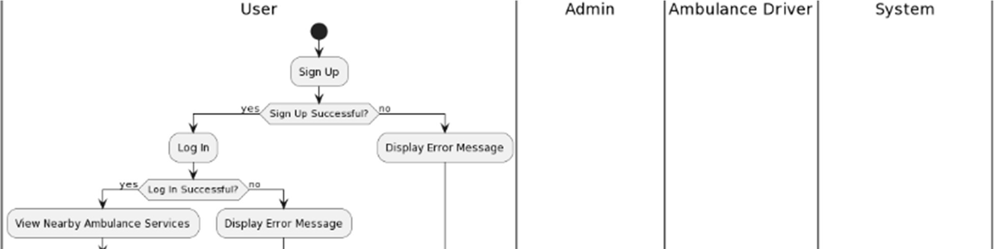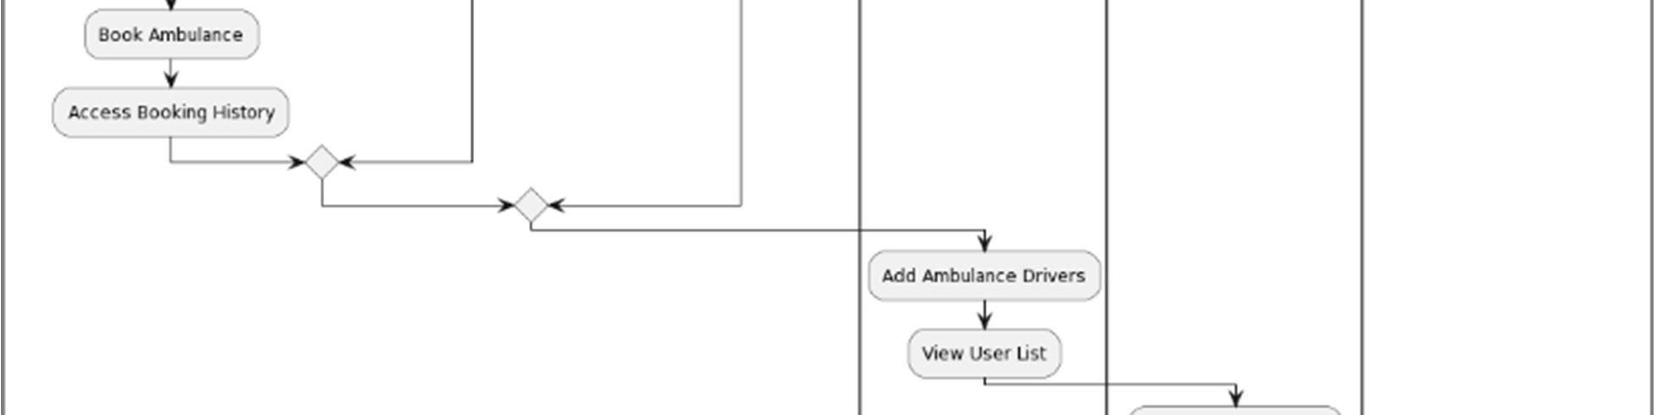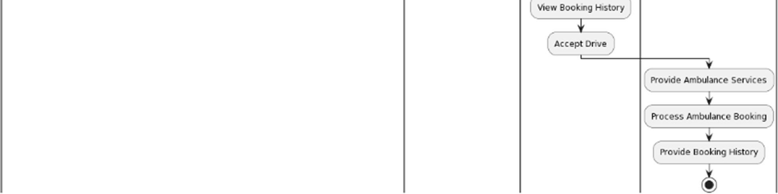

7.5 Activity Diagram

Component Diagram:

Component diagram is a special kind of diagram in UML. The purpose is also different from all other diagrams discussed so far. It does not describe the functionality of the system but it describes the components used to make those functionalities. Thus from that point of view, component diagrams are used to visualize the physical components in a system. These components are libraries, packages, files, etc. Component diagrams can also be described as a static implementation view of a system. Static implementation represents the organization of the components at a particular moment. A single component diagram cannot represent the entire system but a collection of diagrams is used to represent the whole.

The purpose of the component diagram can be summarized as

* + Visualize the components of a system.
  + Construct executable by using forward and reverse engineering.
  + Describe the organization and relationships of the components.

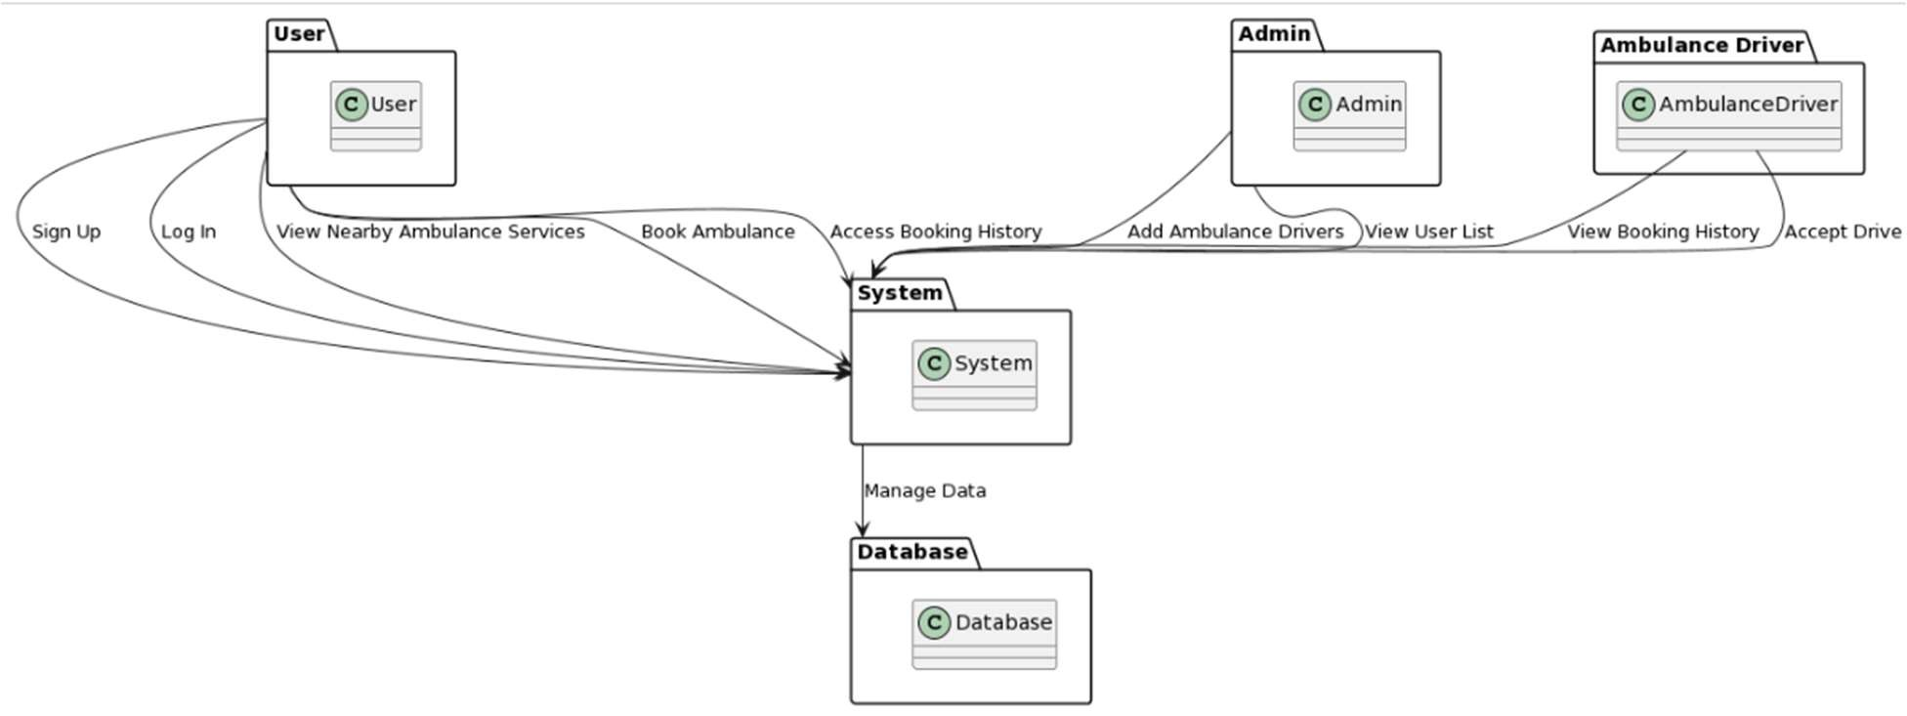

7.6 Component Diagram

Deployment Diagram:

A deployment diagram is a UML diagram type that shows the execution architecture of a system, including nodes such as hardware or software execution environments, and the middleware connecting them. Deployment diagrams are typically used to visualize the physical hardware and software of a system. Using it you can understand how the system will be physically deployed on the hardware. Deployment diagrams help model the hardware topology of a system compared to other UML diagram types which mostly outline the logical components of a system.

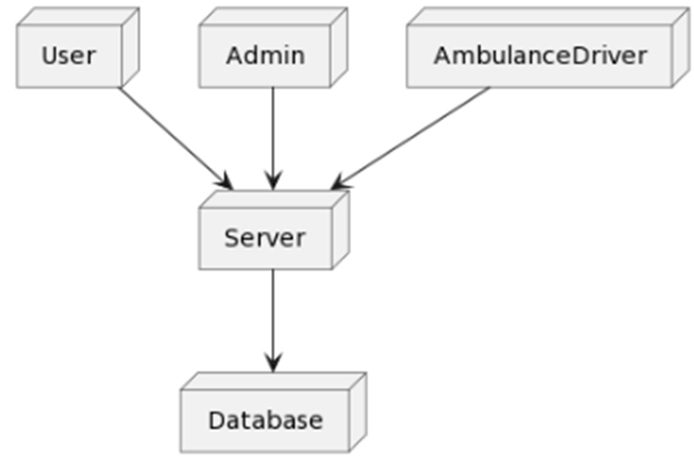

7.7 Deployment Diagram

CHAPTER-8

SYSTEM STUDY

8.1 FEASIBILITY STUDY

The feasibility of the project is analyzed in this phase and business proposal is put forth with a very general plan for the project and some cost estimates. During system analysis the feasibility study of the proposed system is to be carried out. This is to ensure that the proposed system is not a burden to the company. For feasibility analysis, some understanding of the major requirements for the system is essential.

Three key considerations involved in the feasibility analysis are

* + ECONOMICAL FEASIBILITY
  + TECHNICAL FEASIBILITY
  + SOCIAL FEASIBILITY

ECONOMICAL FEASIBILITY

This study is carried out to check the economic impact that the system will have on the organization. The amount of fund that the company can pour into the research and development of the system is limited. The expenditures must be justified. Thus the developed system as well within the budget and this was achieved because most of the technologies used are freely available. Only the customized products had to be purchased.

TECHNICAL FEASIBILITY

This study is carried out to check the technical feasibility, that is, the technical requirements of the system. Any system developed must not have a high demand on the available technical resources. This will lead to high demands on the available technical resources. This will lead to high demands being placed on the client. The developed system must have a modest requirement, as only minimal or null changes are required for implementing this system.

SOCIAL FEASIBILITY

The aspect of study is to check the level of acceptance of the system by the user. This includes the process of training the user to use the system efficiently. The user must not feel threatened by the system, instead must accept it as a necessity. The level of acceptance by the users solely depends on the methods that are employed to educate the user about the system and to make him familiar with it. His level of confidence must be raised so that he is also able to make some constructive criticism, which is welcomed, as he is the final user of the system.

SYSTEM TESTING

The purpose of testing is to discover errors. Testing is the process of trying to discover every conceivable fault or weakness in a work product. It provides a way to check the functionality of components, sub-assemblies, assemblies and/or a finished product It is the process of exercising software with the intent of ensuring that the software system meets its requirements and user expectations and does not fail in an unacceptable manner. There are various types of test. Each test type addresses a specific testing requirement.

8.2 TYPES OF TESTS

UNIT TESTING

Unit testing involves the design of test cases that validate that the internal program logic is functioning properly, and that program inputs produce valid outputs. All decision branches and internal code flow should be validated. It is the testing of individual software units of the application .it is done after the completion of an individual unit before integration. This is a structural testing, that relies on knowledge of its construction and is invasive. Unit tests perform basic tests at component level and test a specific business process, application, and/or system configuration. Unit tests ensure that each unique path of a business process performs accurately to the documented specifications and contains clearly defined inputs and expected results.

INTEGRATION TESTING

Integration tests are designed to test integrated software components to determine if they actually run as one program. Testing is event driven and is more concerned with the basic outcome of screens or fields. Integration tests demonstrate that although the components were individually satisfaction, as shown by successfully unit testing, the combination of components is correct and consistent. Integration testing is specifically aimed at exposing the problems that arise from the combination of components.

FUNCTIONAL TEST

Functional tests provide systematic demonstrations that functions tested are available as specified by the business and technical requirements, system documentation, and user manuals.

Functional testing is centered on the following items:

Valid Input : identified classes of valid input must be accepted.

Invalid Input : identified classes of invalid input must be rejected.

Functions : identified functions must be exercised.

Output : identified classes of application outputs must be exercised.

Systems/Procedures: interfacing systems or procedures must be invoked. Organization and preparation of functional tests is focused on requirements, key functions, or special test cases. In addition, systematic coverage pertaining to identify Business process flows; data fields, predefined processes, and successive processes must be considered for testing. Before functional testing is complete, additional tests are identified and the effective value of current tests is determined.

SYSTEM TEST

System testing ensures that the entire integrated software system meets requirements. It tests a configuration to ensure known and predictable results. An example of system testing is the configuration-oriented system integration test. System testing is based on process descriptions and flows, emphasizing pre-driven process links and integration points.

WHITE BOX TESTING

White Box Testing is a testing in which in which the software tester has knowledge of the inner workings, structure and language of the software, or at least its purpose. It is purpose. It is used to test areas that cannot be reached from a black box level.

BLACK BOX TESTING

Black Box Testing is testing the software without any knowledge of the inner workings, structure or language of the module being tested. Black box tests, as most other kinds of tests, must be written from a definitive source document, such as specification or requirements document, such as specification or requirements document. It is a testing in which the software under test is treated, as a black box. you cannot “see” into it. The test provides inputs and responds to outputs without considering how the software works.

UNIT TESTING:

Unit testing is usually conducted as part of a combined code and unit test phase of the software lifecycle, although it is not uncommon for coding and unit testing to be conducted as two distinct phases.

Test strategy and approach

Field testing will be performed manually and functional tests will be written in detail.

Test objectives

* All field entries must work properly.
* Pages must be activated from the identified link.
* The entry screen, messages and responses must not be delayed.

Features to be tested

* Verify that the entries are of the correct format
* No duplicate entries should be allowed

All links should take the user to the correct page

INTEGRATION TESTINGSS

Software integration testing is the incremental integration testing of two or more integrated software components on a single platform to produce failures caused by interface defects. The task of the integration test is to check that components or software applications, e.g., components in a software system or – one step up – software applications at the company level – interact without error.

Test Results: All the test cases mentioned above passed successfully. No defects encountered.

ACCEPTANCE TESTING

User Acceptance Testing is a critical phase of any project and requires significant participation by the end user. It also ensures that the system meets the functional requirements.

Test Results: All the test cases mentioned above passed successfully. No defects encountered.

TESTING CASES

|  |  |  |  |  |  |  |  |
| --- | --- | --- | --- | --- | --- | --- | --- |
| Test case id | Test Scenario | Test Steps | Prerequisites | Test Data | Expected  result | Actual  result | Test  status |
| #CVD001 | To authenticate a successful signup with user data | * User   navigate the signup page   * Enter the   valid user data   * Click on   signup button | User data | Username  Password  Mobile Email location | When the user submit the user data, data should be store in database successfully | As  Expected | Pass |
| #CVD002 | To authenticate a successful login with  user data | * User   navigate the login page   * Enter the   valid username  ,password   * Click on   login button | Username, password | Username, password | When the user submit  the user data, data should be authenticate successfully | As  Expected | Pass |

CHAPTER-9

TIMELINE FOR EXECUTION OF PROJECT

(GANTT CHART)

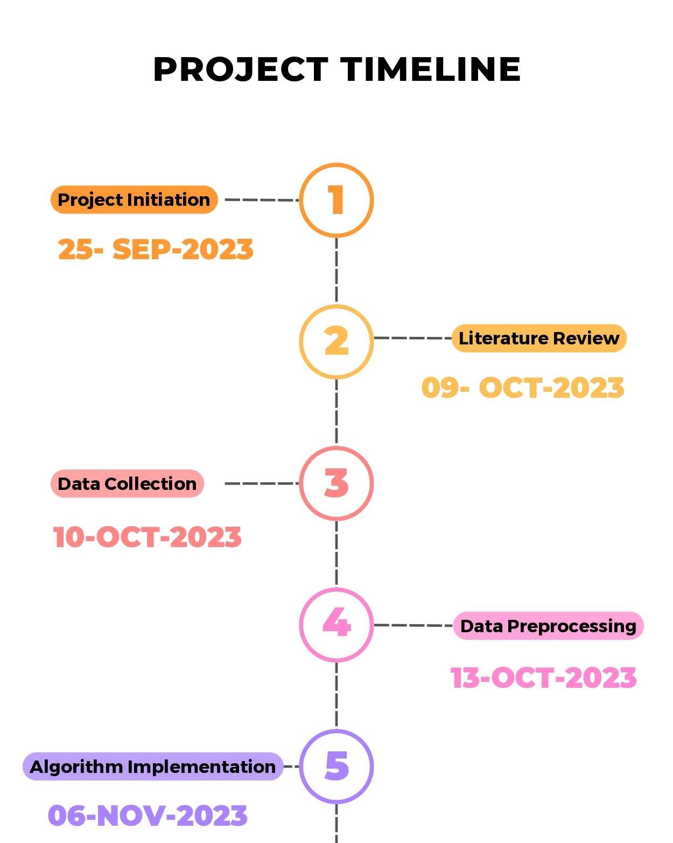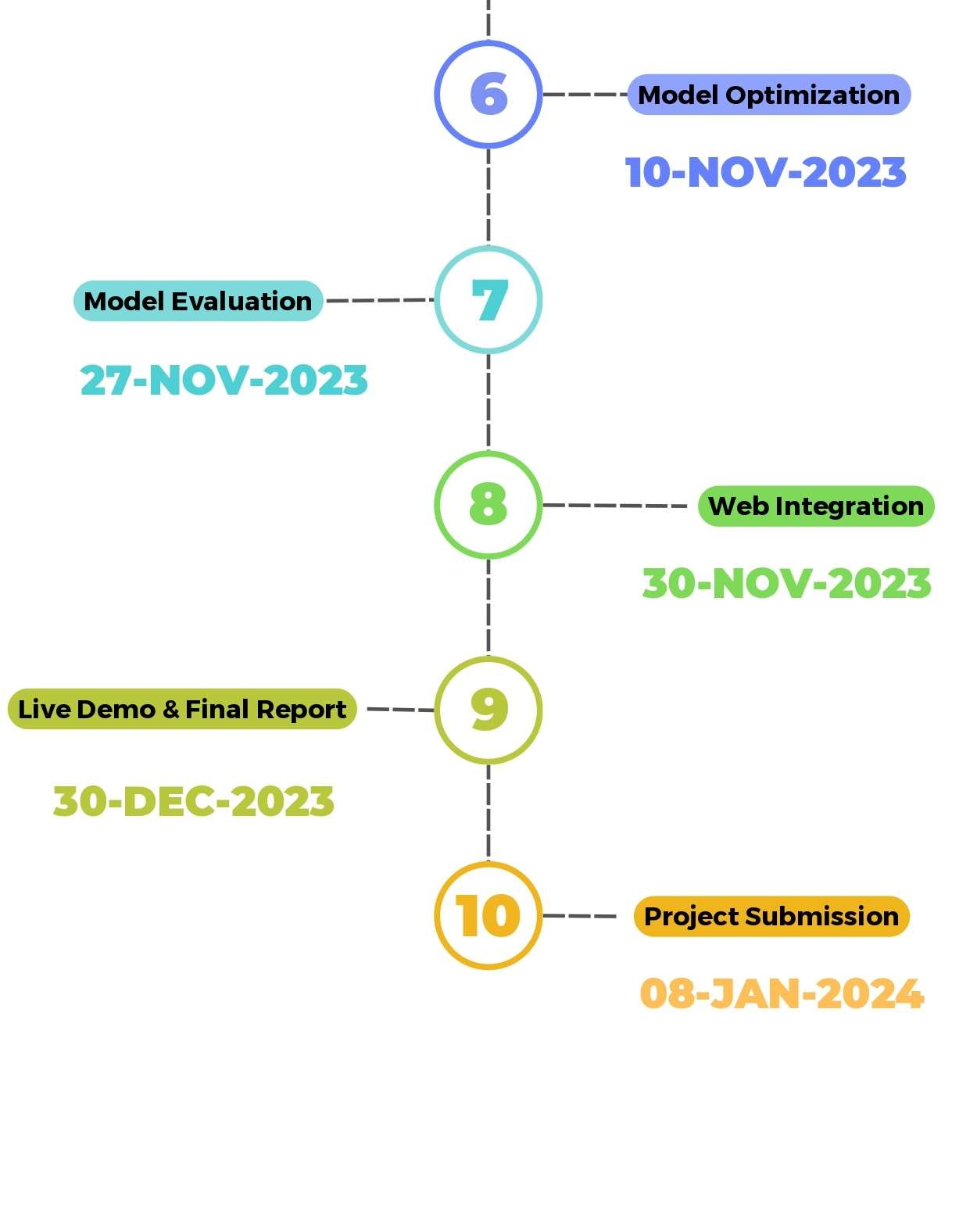

CHAPTER-10

OUTCOMES

* In our study, we explore two distinct scenarios characterized by specific numerical values:

* Case 1:
* Number of Hospitals (N): 2 or 4
* Average Arrival Rate (λ): 35.94 patients/hour
* Percentage of Emergency Patients (p): 44.44%
* Maximum Hospital Capacity (M): 5 patients
* Treatment Time (T): 15 minutes

* Case 2:
* Number of Hospitals (N): 2 or 4
* Average Arrival Rate (λ): 35.94 patients/hour
* Percentage of Emergency Patients (p): 44.44%
* Varying Capacities (M) for Hospitals 1, 2, 3, and 4: 4, 6, 3, and 7 patients, respectively
* Treatment Time (T): 15 minutes

CHAPTER-11

RESULTS AND DISCUSSIONS

* In Case 1, the simulation involves two hospitals, omitting hospitals 3 and 4. Additionally, in Case 2, we introduce a traffic slowdown around hospital 1, reflecting a reduced speed on inner roads (from 40 km/h to a range of 5 km/h to 25 km/h), potentially caused by factors such as accidents or construction.
* The simulation results for Case 1, illustrated in Figures 2 and 3, reveal a reduction in response time and travel time with an increasing number of ambulance vehicles per hospital. However, Figure 4 indicates that waiting time at hospitals remains unchanged with varying ambulance vehicle numbers. The transition from two to four hospitals significantly enhances all three performance metrics. Although the integration of smart health technologies, providing real-time traffic and hospital waiting information, exhibits modest improvement in Case 1, the impact is limited due to uniform capacities across hospitals and uniform traffic conditions citywide.
* In Case 2, depicted in Figures 5, 6, and 7, substantial improvements are observed with the utilization of smart health technologies, particularly in scenarios involving nonuniform hospital capacities and traffic slowdown around hospital 1. Notably, with two hospitals and four ambulance vehicles per hospital, smart health implementation leads to noteworthy reductions: from 35 to 25 minutes in response time, 26 to 16 minutes in travel time, and 15.1 to 10 minutes in waiting time.

* These findings underscore the significant benefits of smart health technologies, particularly in situations where non-uniform conditions, such as varying hospital capacities and localized traffic issues, are present. The integration of real-time information enhances the efficiency of ambulance service operations, optimizing response times, travel times, and waiting times at hospitals. Such insights emphasize the potential impact of smart health systems in improving emergency medical services.

CHAPTER-12

CONCLUSION

Ambulance service system can have multiple functions and also provides more benefits to users. With increased features like tracking of ambulance lively . This will help the admin to track the ambulance driver. This helps the user and ambulance driver to make more comfort.

* In conclusion, the proposed Android application for viewing nearby ambulance services is a highly valuable tool for anyone in need of urgent medical attention. The application leverages location-based services to quickly identify the nearest available ambulance services, providing users with real-time information on estimated arrival times and the ambulance's location. The intuitive design and easy-to-use features of the application make it simple and convenient for users to book an ambulance and view their booking details in real-time. With this application, users can have peace of mind knowing that they have a reliable and efficient way to access emergency medical services whenever they need them. Overall, the proposed system has the potential to greatly improve emergency response times and save lives, making it a valuable addition to any community.
* One pivotal factor contributing to the escalating demand for ambulance services is the ageing population. Studies consistently demonstrate a correlation between increasing age and a higher likelihood of ambulance use. The rise can be attributed to the growing prevalence of chronic medical conditions and age-related acute illnesses, emphasizing the need for tailored healthcare solutions for the elderly. Social support dynamics further compound this trend, with individuals living alone or lacking alternative transportation options exhibiting a greater inclination to seek emergency ambulance services. The transformation of communities into more isolated, single-person households adds complexity to the challenges faced by ambulance services.
* Pricing and accessibility emerge as significant drivers affecting ambulance utilization patterns. The evidence suggests that entitlements to free transport or participation in low-cost subscription schemes increase reliance on ambulance services. The concept of moral hazard, wherein reduced out-of-pocket expenses lead to heightened service use, highlights the intricate interplay between financial considerations and demand for emergency healthcare. Concurrently, shifts in primary care practices, such as shorter working hours and part-time availability of general practitioners, contribute to the rising dependence on emergency services.

REFERENCES

[1] “.P. Arunmozhi and P.Joseph William, “Automatic Ambulance Rescue System Using Shortest Path Finding Algorithm,” in International Journal of Science and Research(IJSR),5th May 2014.

[2] “RajeshwariSundhar , SanthoshHebbar and VaraprasadGolla, “Implementing Intelligent Traffic Control System for Congestion Control, Ambulance Clearance and Stolen Vehicle Detection,” in IEEE Sensors Journal, 2nd Feb 2015.CrossRef

[3] SabyasachiPatra, KarishmaVelisetty and Prathamesh Patel, “Location Based Tracking,” in International Journal of Engineering Research and Development, 12th Feb 2014.

[4] ”Ayesha Khan, ParulBhanarkar and PragatiPatil, “RSA Encryption Technique based on Geo Location,” in International Journal of Advanced Research in Computer Science and Software Engineering, 4th Apr 2013

[5] ”Dr. KhannaSamratVivekanandOmprakash, Mr. Pritesh Patel, “Application Of Google API and KML to Draw Path From Source to Destination on Android Phone,” in International Journal of Advanced Engineering technology, 1stMar 2013.

[6] BhandariParchi, DalviKasturi and ChopadePriyanka,” Intelligent Accident –Detection And Ambulance - Rescue System,” in International Journal of Scientific and Technology Research, 6th June 2014.

[7] ”GeoDataSource. (2016, August).Retrieved fromwww.geodatasource.com.

[8] ”Deepak Sharma. (2016, August) Retrieved from deepak-sharma.net.

[9] R. S. Jagtap et al., "Design and Implementation of a Smart Ambulance System for Efficient Patient Care." International Journal of Scientific Research in Network Security and Communication, vol. 4, no. 4, 2016.

[10]M. K. R. Shaik and A. V. R. Kumar, "Smart Ambulance System for Efficient Emergency Medical Services." International Journal of Computer Science and Engineering (IJCSE), vol. 7, no. 1, 2018.

APPENDIX-A

PSUEDOCODE

MainActivity.xml

*<?***xml version="1.0" encoding="utf-8"***?>*<**RelativeLayout xmlns:android="http://schemas.android.com/apk/res/android"  
 xmlns:app="http://schemas.android.com/apk/res-auto"  
 xmlns:tools="http://schemas.android.com/tools"  
 android:layout_width="match_parent"  
 android:layout_height="match_parent"  
 tools:context=".MainActivity"**>  
  
 <**ScrollView  
 android:layout_width="match_parent"  
 android:layout_height="match_parent"**>  
  
 <**LinearLayout  
 android:layout_width="match_parent"  
 android:layout_height="800dp"  
 android:orientation="vertical"**>  
  
 <**TextView  
 android:layout_width="wrap_content"  
 android:layout_height="wrap_content"  
 android:layout_centerHorizontal="true"  
 android:layout_gravity="center_horizontal"  
 android:layout_marginTop="50dp"  
 android:text="Ambulance Booking App"  
 android:textSize="40dp"  
 android:gravity="center"  
 android:textStyle="bold"** />  
  
 <**ImageView  
 android:id="@+id/imageView"  
 android:layout_width="match_parent"  
 android:layout_height="300dp"  
 app:srcCompat="@drawable/ambulancelogo"** />  
  
 <**Button  
 android:id="@+id/startappbtn"  
 android:layout_width="match_parent"  
 android:layout_height="75dp"  
 android:layout_marginStart="10dp"  
 android:layout_marginLeft="50dp"  
 android:layout_marginTop="50dp"  
 android:layout_marginEnd="10dp"  
 android:layout_marginBottom="10dp"  
 android:background="@drawable/shapesignup"  
 android:shadowColor="@android:color/transparent"  
 android:text="Start App"  
 android:textColor="@color/white"** />  
  
 <**Button  
 android:id="@+id/exitbtn"  
 android:layout_width="match_parent"  
 android:layout_height="75dp"  
 android:layout_marginStart="10dp"  
 android:layout_marginLeft="50dp"  
 android:layout_marginTop="50dp"  
 android:layout_marginEnd="10dp"  
 android:layout_marginBottom="10dp"  
 android:background="@drawable/shapesignup"  
 android:shadowColor="@android:color/transparent"  
 android:text="Exit"  
 android:textColor="@color/white"** />  
  
  
 </**LinearLayout**>  
 </**ScrollView**>  
  
</**RelativeLayout**>

MainActivity.java

**package** com.example.ambulanceserviceapp;  
  
**import** android.content.Intent;  
**import** android.os.Bundle;  
**import** android.view.View;  
**import** android.widget.Button;  
  
**import** androidx.appcompat.app.AppCompatActivity;  
  
**public class** MainActivity **extends** AppCompatActivity {  
**private** Button **startappbtn**,**exitBtn**;  
 @Override  
 **protected void** onCreate(Bundle savedInstanceState) {  
 **super**.onCreate(savedInstanceState);  
 setContentView(R.layout.***activity_main***);  
  
 **startappbtn**=(Button)findViewById(R.id.***startappbtn***);  
 **exitBtn** = (Button) findViewById(R.id.***exitbtn***);  
  
 **startappbtn**.setOnClickListener(**new** View.OnClickListener() {  
 @Override  
 **public void** onClick(View v) {  
 Intent intent = **new** Intent(getApplicationContext(), MainAppActivity.**class**);  
 startActivity(intent);  
 }  
 });  
  
 **exitBtn**.setOnClickListener(**new** View.OnClickListener() {  
 @Override  
 **public void** onClick(View v) {  
 *//Intent intent = new Intent(getApplicationContext(), MainActivity.class);  
 // on below line we are finishing activity.* MainActivity.**this**.finish();  
 *// on below line we are exiting our activity* finishAffinity();  
 *//startActivity(intent);* }  
 });  
  
 }  
}

APPENDIX-B

SCREENSHOTS

